Fall 2025 - Assignment 2 Detailed Development Document
Submitted by: Isaac Ng

Design Document
The following is the detailed development document to provide the details steps that is not given in the previous design document.

Developing Environment
The following is the developing environment used in this project:
- Python 3.13.9
- CrewAI v1.3.0
- MongoDB Community 8.2.1
- Docker Desktop 4.49.0
- LLM: gemini-2.0-flash-lite (prototype use)
- IDE: Visual Studio Code 1.105.1

Use case definition
Brief Description: | User input action or information to the system to progress the story
Precondition(s): | The game started, and the initial message was displayed
Post Condition(s): | The system displays and updates the narrative and the story progress.
Process Steps
1 | The Interface agent receives the prompt from the user, and passes it to Narrator agent
2 | The Narrator agent looks in the prompt and identifies the action.
3 | Narrator agent gets the action difficulty from the Judge agent and pass to interface agent.
4 | The interface agent displays the difficulty and is pending for player's decision. If continue the action, interface do a random roll to determine the success or not.
5 | Judge agent evaluates and executes the consequence/effect based on the action result and inform the Narrator agent and NPC agents.
6 | NPC agents evaluate correspond reaction and check its difficulty from the judge
7 | NPC agents do a random roll to determine the success or not, and info the judge agent the result.
8 | Judge agent evaluates and executes the consequence/effect based on the action result and inform the Narrator agent.
9 | Narrator agent generates the user’s action and NPC agent’s reaction narrative.
10 | Narrator agent updates the game state according to both NPC and user narrative if needed
11 | Narrator agent passes NPC agent’s reaction narrative and user action narrative to interface agent
12 | The interface agent shows the narratives to user and progresses the story.
Exceptions
2a | The user’s prompt consists of invalid, conflict, ambiguous information or action | Narrator agent replies to interface to clarify the prompt
3a | The judge agent determines the action do not need difficulty check (it is impossible to success, or it is too easy) | Judge agent informs the narrator agent and NPC agents about the effect of action (Jump to 6) and skip the difficulty check in interface agent.
6a | Multiple NPC agents try to react to the user action | Based on the NPC information to determine the order of execution. Append the previous player and NPC action to judge agent for evaluating the difficulty.
Relationship
Initiator | User
Collaborator | Interface agent, Narrator agent, Jude agent, NPC agents
Data requirements
User prompt | A text input by the user, which describe the action of the main character.
pre-defined story | A text document defines the outline, objective and stages of the story. Each stage consists of the environment description, NPCs and story information.
Rule document | A text document defines the terminology and the game rule logic. It is based on the Dungeon and Dragon System Reference Document (DnD SRD) which allow public use.
Game State | A Json file that stores the status of the story, consists of stages, main character and list of previous actions.  In stages, it contains the changes on NPCs status and environment.  In main character, it contains the story progress based on the outline, and the current status.
Game Statistic | A database contains the value, effect, description of the game object, including enemy, item, class, ability.  This is based on the https://github.com/5e-bits/5e-database. The data are all within the DnD SRD which allows public use.

Detailed class diagram
Here is the revised function of agents:
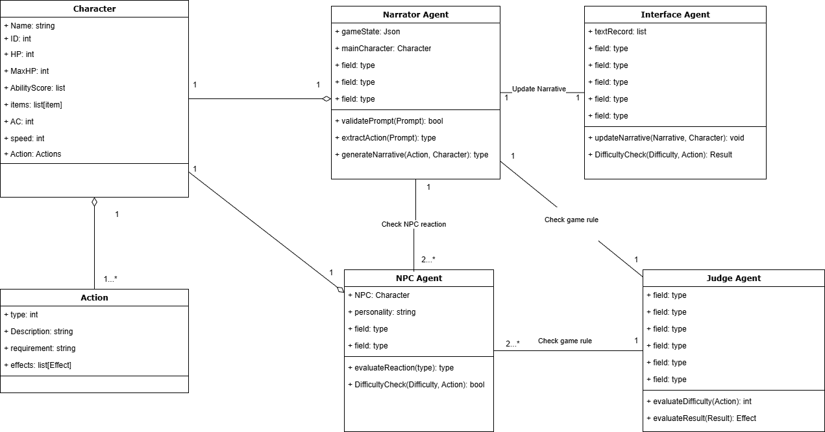

Message sequence chart
Here is the revised sequence chart: 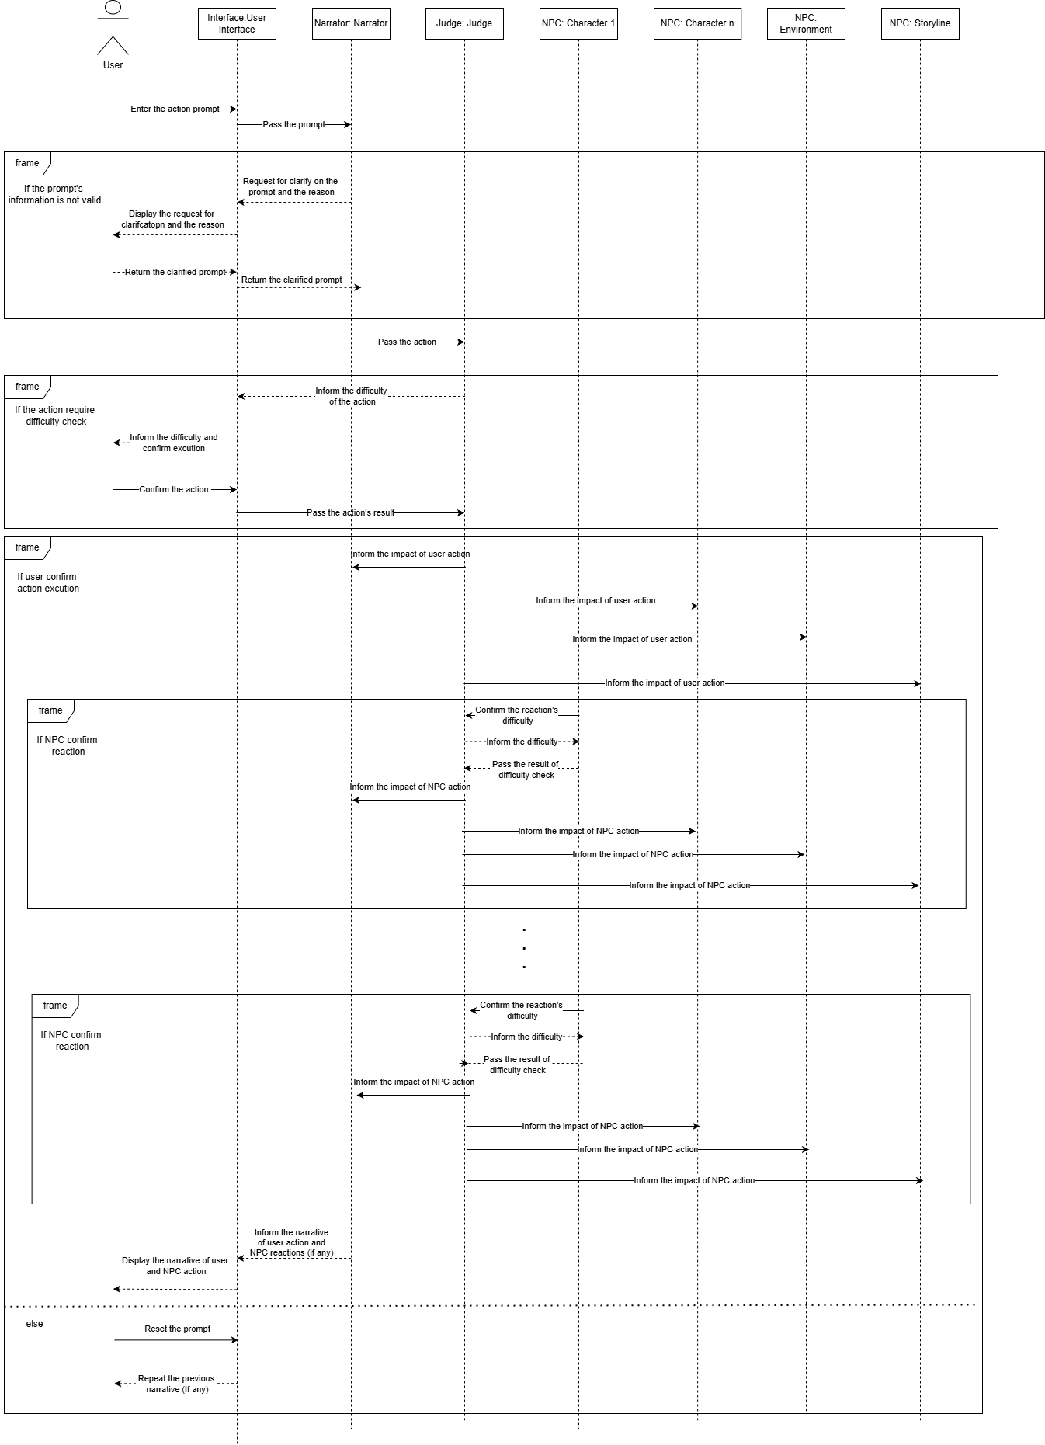

Here is the message of Conversations
    - Get user prompt
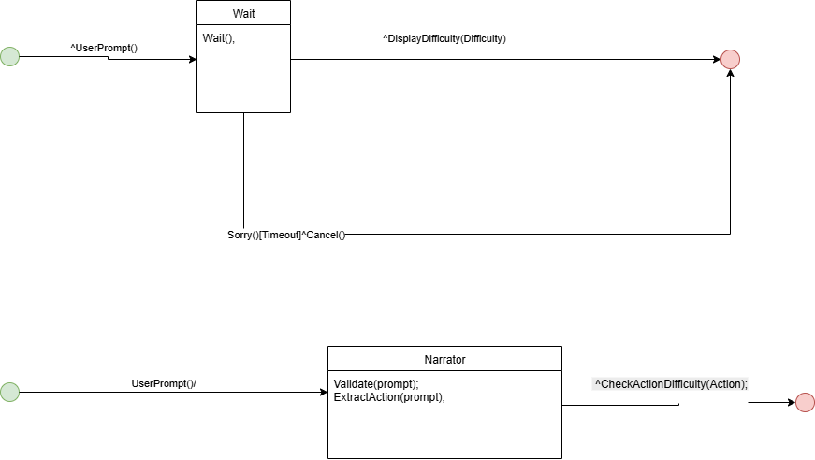
Check Action Difficulty
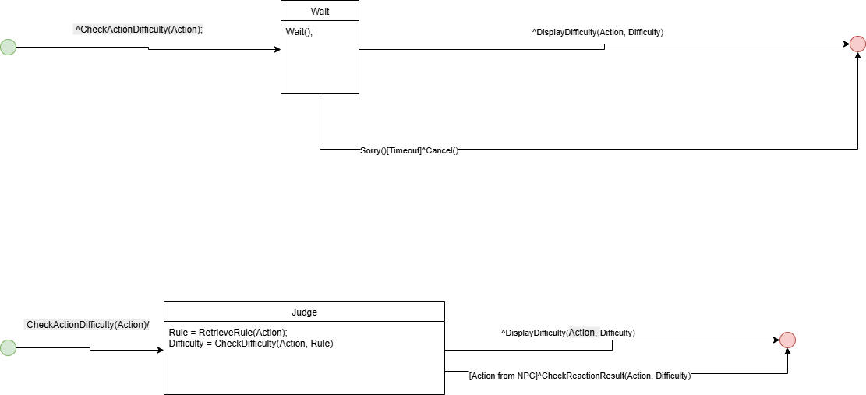
Display Difficulty

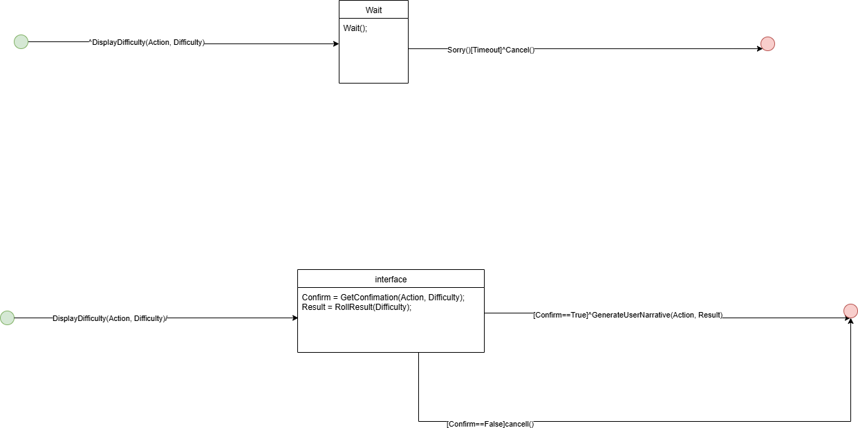
Generate User Narrative

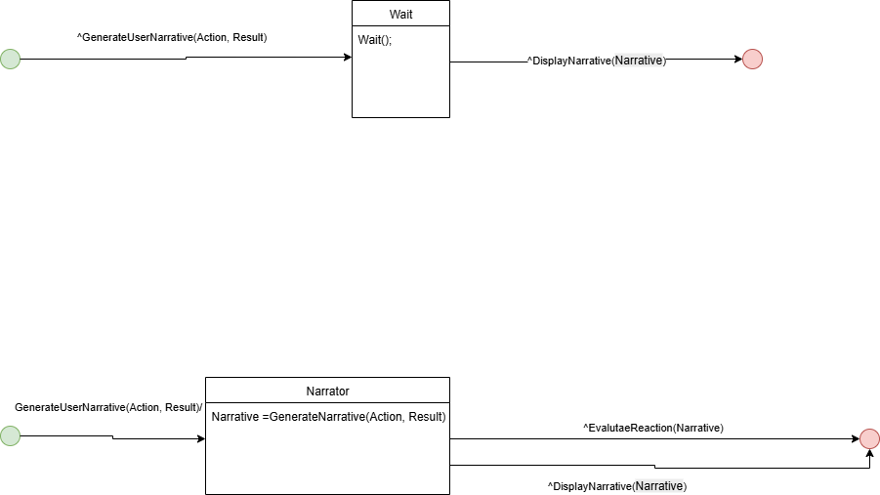

Evaluate Reaction
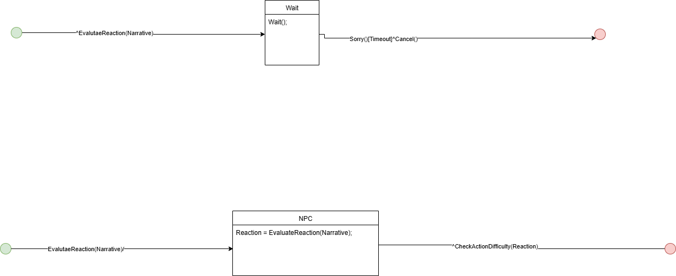

Check Reaction Result

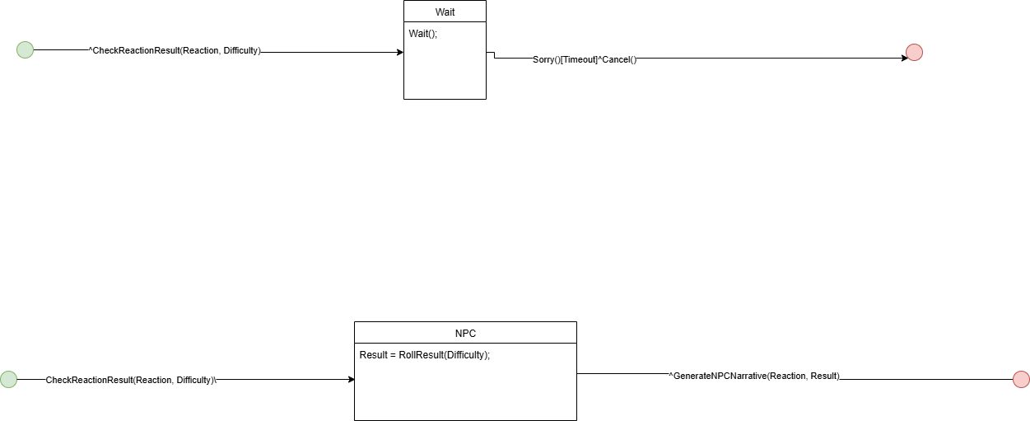

Generate NPC Narrative


Display Narrative
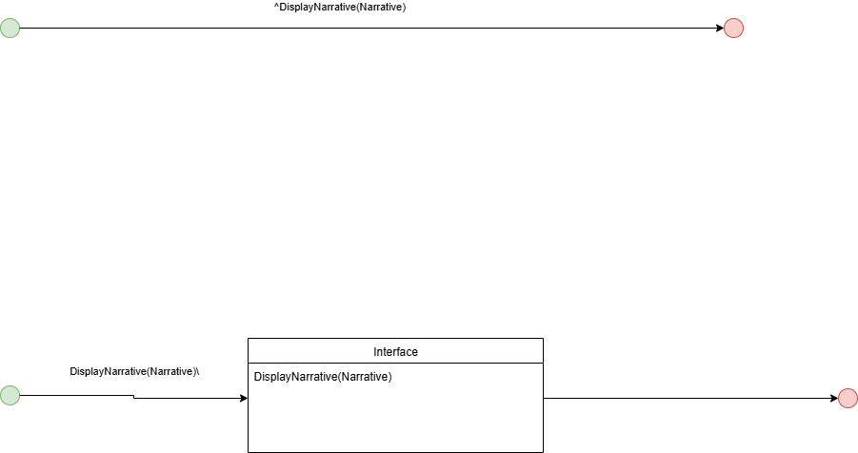

Data specification
Most data are stored in local MongoDB Community 8.2, and running on docker.
Most data are retrieved in https://github.com/5e-bits/5e-database, here is the list of collections:
2014-ability-scores | 2014-magic-schools | 2024-ability-scores
2014-alignments | 2014-monsters | 2024-alignments
2014-backgrounds | 2014-proficiencies | 2024-collections
2014-classes | 2014-races | 2024-conditions
2014-collections | 2014-rule-sections | 2024-damage-types
2014-conditions | 2014-rules | 2024-equipment
2014-damage-types | 2014-skills | 2024-equipment-categories
2014-equipment | 2014-spells | 2024-languages
2014-equipment-categories | 2014-subclasses | 2024-magic-schools
2014-feats | 2014-subraces | 2024-skills
2014-features | 2014-traits | 2024-weapon-mastery-properties
2014-languages | 2014-weapon-properties | 2024-weapon-properties
2014-levels | 2024-weapon-mastery-properties
2014-magic-items | 2024-weapon-properties

Strings data that needed to be retrieve by LLM are generated the embeddings and vector search index.
The diagram is generated by Moon Modeler 11.0.0, reverse engine from local MonogoDB
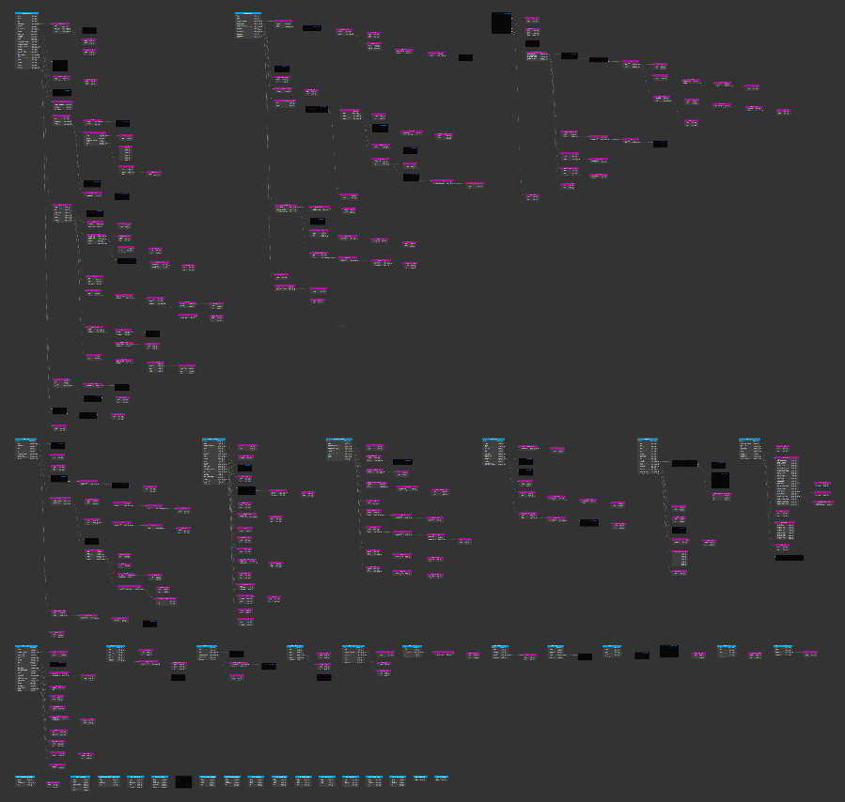
We are only using the 2014 collections and some of the fields, and here introduce some significant collections:

2014-monsters
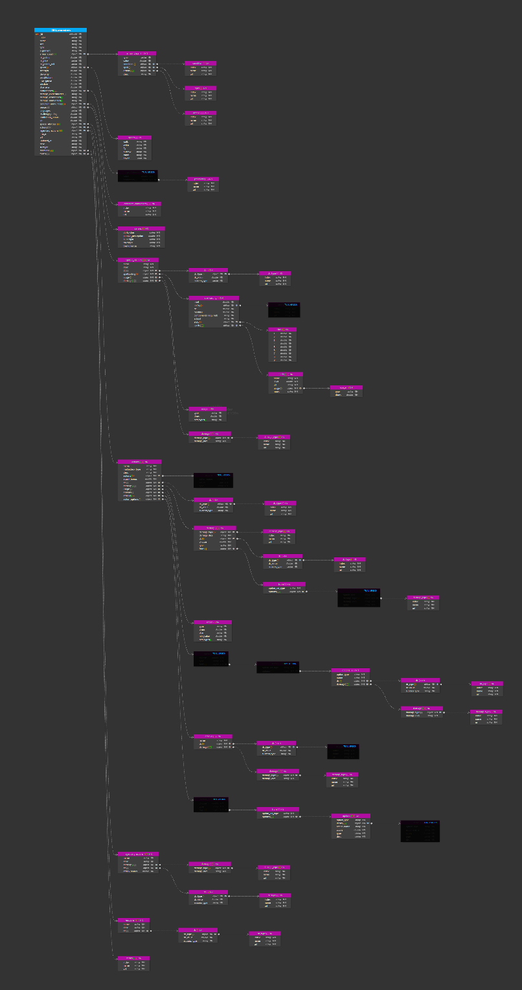
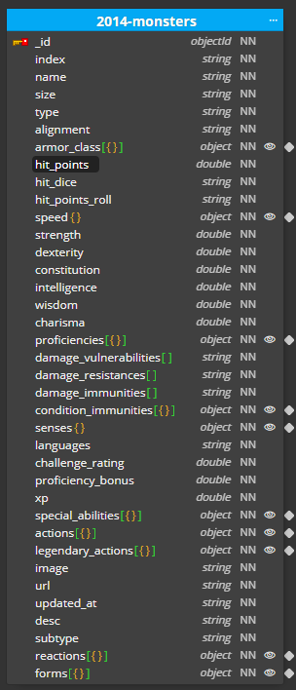

2014-rules
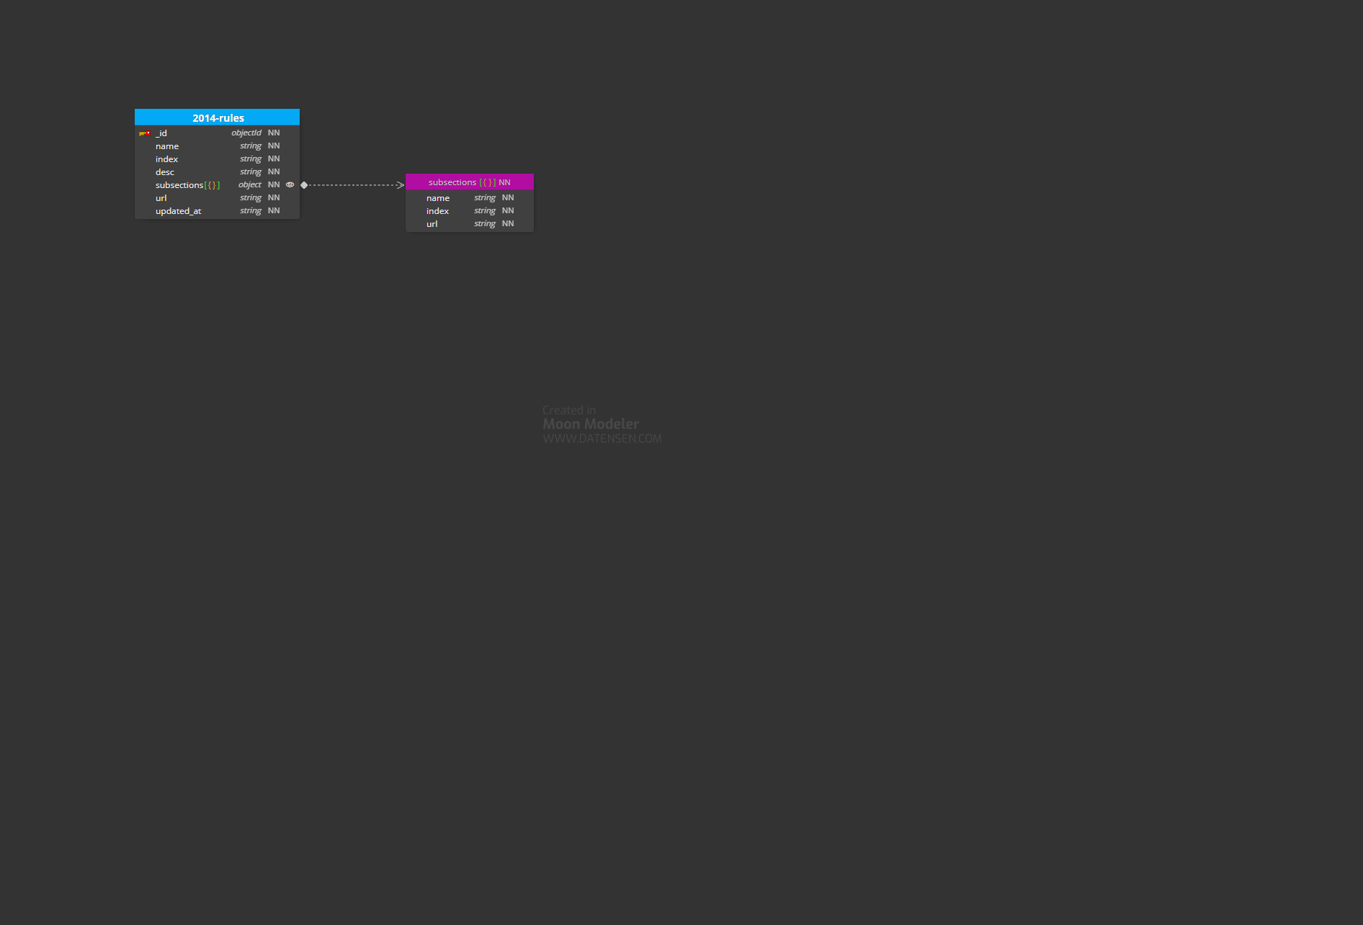

2014-spells
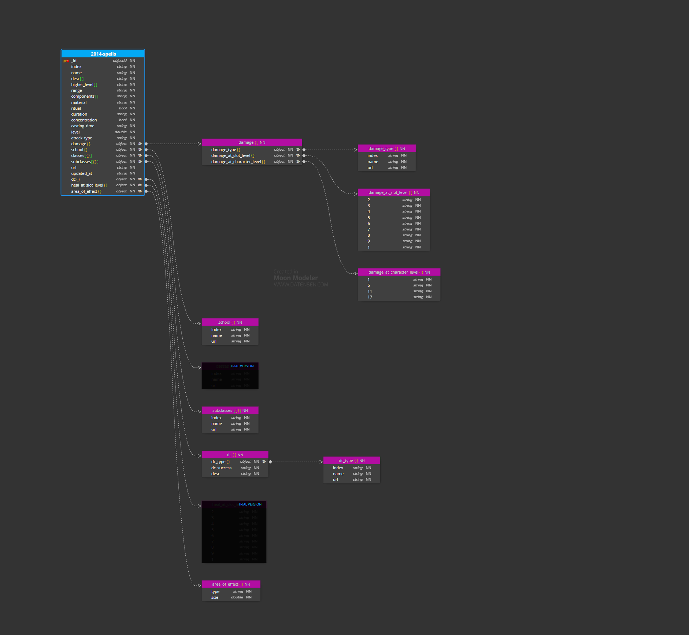

Other collections
There are some data that are not coming from the 5e-databas, which specifically the pre-defined story. Here is the structure of them:
Table Name | Attributes | Type | Description
pre-defined story | _id | ObjectId
 | name | sting
 | stages[] | object
 | objective | sting
 | outline | sting

Table Name | Attributes | Type | Description
Stage | _id | ObjectId
 | name | sting
 | envDesc | string | Desciption on the environment element, including outlook
 | NPCs[] | Object
 | venues[] | sting
 | storyDesc | string
 | action[] | Object

Table Name | Attributes | Type | Description
Venue | _id | ObjectId
 | name | sting
 | envDesc | string
 | NPCs[] | Object
 | connectVenues[] | Object
 | storyDesc | string
 | action[] | Object

Table Name | Attributes | Type | Description
NPC | _id | ObjectId
 | name | sting
 | Desc | string
 | stat | 2014-monsters
 | action[] | Object
 | Intention | string
 | personality | string

